Sales Analysis for Pizza

KPI-I

- Total revenue generated.
select SUM(total_price) Total_Revenue from pizza_sales;

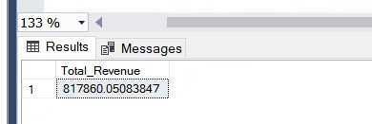

- Average order value.
select (SUM(total_price)/(count(distinct order_id))) Average_Order_Value from pizza_sales;
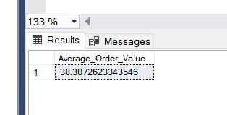

- Total pizza sold
select SUM(quantity) Total_pizza_sold from pizza_sales;
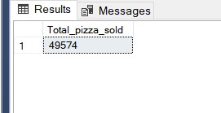

- Total orders
select count(distinct order_id) Total_orders from pizza_sales;

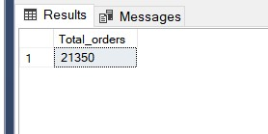

- Average pizza per order
select (SUM(quantity)/Count(distinct order_id)) Average_pizza_per_order from pizza_sales;

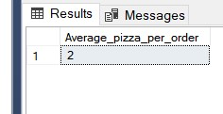

KPI-II

- Daily trend for orders.
- Hourly Trend for total orders.
- Percentage of sales by pizza category.
- Percentage of sales by pizza size.
- Total pizza sold per category .
- Top 5 Sales.
- Bottom 5 Sales.

